**Aphasia**

[Neurological Disorders (Second Edition)](https://www.sciencedirect.com/science/book/9780121258313)

Course and Treatment

Chapter 25 – Aphasia

This chapter presents a study on the clinical aspects of aphasia. In most adults the regions that are most vital for symbolic communication are located in the perisylvian region of the left cerebral hemisphere. Depending on the size and location of the damaged area there may be preferential loss of the capability to express or to comprehend spoken or written language. The set of clinical presentations denoting any acquired disorder of language is labeled with the general term aphasia. Aphasia must be distinguished from abnormalities of the motor or sensory systems that are utilized by, but are outside of the language network. At the border between aphasic and nonaphasic deficits are certain uncommon perceptual deficits that are specific for linguistic sensory information, such as "pure word deafness" and "pure word blindness." Most investigators classify these, as well as other forms of alexia and the various agraphias, under the general classification of aphasia or aphasia-related syndromes. It is important to distinguish between disturbances of the language network and those of other higher cortical modules, including those mediating memory, attention, and executive function. Despite these distinctions, aphasia frequently coexists with one or more motor, sensory, or cognitive abnormalities. The chapter discusses classical aphasiology and cognitive neurolinguistics, cortical lesions affecting language, and subcortical aphasic syndromes. The discussion on principles of therapy include reactivation of linguistic functions, pragmatic therapy, pharmacotherapy, and others.

*This section addresses the clinical aspects of aphasia and treatment principles. Depending on the extent and location of damage in the brain's language areas, the abilities to express or comprehend language may be affected. Treatment approaches involve various methods such as restoring language functions, pragmatic therapy, and pharmacotherapy.*

**American Speech-Language-Hearing Association**

**National Aphasia Association**

**National Institute on Deafness and Other Comminication Disorders**

What is Aphasia: **Aphasia** is an acquired neurogenic language disorder resulting from an injury to the brain, typically the left hemisphere, that affects the functioning of core elements of the language network. Aphasia involves varying degrees of impairment in four primary areas:

spoken language expression

written expression

spoken language comprehension

reading comprehension

Aphasia may also result from neurodegenerative disease. For example, primary progressive aphasia is a subtype of frontotemporal dementia in which language capabilities become progressively impaired.

**What types of aphasia are there?**

Aphasia is often described as nonfluent or fluent, based on the typical length of utterance and amount of meaningful content a person produces. There are various subtypes of aphasia within these two categories based on differences in other aspects of expressive and receptive language skills. Clinicians should be aware that a person’s presentation may not fit into a single aphasia type or subtype, and should use care if designating a type or subtype. Aphasia’s presentation may also change over time as communication improves with recovery.

**Incidence and Prevalence of Aphasia:**

* **Incidence:** Refers to the number of new cases within a specific time period.
* **Prevalence:** Refers to the number of people living with aphasia during a specific time period.

**Aphasia in the United States:**

* Approximately 100,000–180,000 people develop aphasia each year.
* It is estimated that 2–4 million people live with aphasia.

**Causes of Aphasia:**

* Traumatic brain injury (TBI), brain tumors, infections, dementia, or other neurodegenerative diseases can lead to aphasia. However, it most commonly occurs after a stroke.
* It is estimated that about 25–50% of all stroke cases result in aphasia.
* Aphasia is generally more common in older individuals. While 15% of individuals under the age of 65 experience aphasia after their first ischemic stroke, this rate rises to 43% in individuals aged 85 and older.

**Aphasia Related to TBI:**

* There are very few statistics regarding aphasia caused by TBI. In one study, 1% of veterans from the Iraq and Afghanistan wars were diagnosed with aphasia following TBI.
* Two other studies found that 13–19% of individuals with TBI developed aphasia.
* The prevalence of TBI-related aphasia is estimated to be between 64,653 and 1,228,421.

**Aphasia Related to Brain Tumors:**

* One study estimated the incidence of aphasia resulting from primary brain tumors to be between 30% and 50%. Based on this data, the prevalence of tumor-related aphasia is estimated to be between 198,028 and 330,048.

metin, ekran görüntüsü, dikdörtgen, diyagram içeren bir resim

Açıklama otomatik olarak oluşturuldu

# Signs and Symptoms:

**Signs and Symptoms:**

The signs and symptoms of aphasia vary depending on the location and extent of the damage and can affect verbal expression, auditory comprehension, reading, and writing skills. Anomia (difficulty finding words) is universal in individuals with aphasia. Alexia refers to difficulty reading, and agraphia refers to difficulty writing, both of which can occur together or separately.

Aphasia can affect bilingual individuals differently, depending on how and when the languages were learned and used.

**Common Symptoms:**

* **Speech:** Difficulty finding words, using nonsensical words, neologisms (inventing new words), word or sound substitutions (phonemic and semantic paraphasias), telegraphic speech (omitting conjunctions), and lack of awareness of mistakes.
* **Comprehension:** Difficulty understanding complex sentences, struggling to understand long or fast speech, and failing to grasp figurative language.
* **Writing:** Difficulty writing words or sentences, writing nonsensical syllables, and making grammar and spelling errors.
* **Reading:** Difficulty recognizing and understanding words, and trouble understanding functional words (conjunctions, pronouns).

# Causess/ Roles and Responsibilites/ Assesments:

# Causes of Aphasia

Aphasia is primarily caused by damage to the brain's language network, usually due to injury in the left hemisphere. However, in some rare cases, right-hemisphere damage can also lead to aphasia, particularly in left-handed individuals who may have language networks that are more bilaterally organized or located in the right hemisphere. This phenomenon is known as crossed aphasia when it occurs in right-handed individuals.

The most common causes of aphasia include:

**Stroke:**

**Ischemic Stroke:** Results from a blockage that disrupts blood flow to a part of the brain.

**Hemorrhagic Stroke:** Occurs due to a ruptured blood vessel, causing damage to surrounding brain tissue.

**Traumatic Brain Injury:** Damage caused by external forces, such as a blow to the head.

**Brain Tumors:** Abnormal growths in the brain that can interfere with normal functioning.

**Brain Surgery:** Surgical procedures that may inadvertently damage language areas.

**Brain Infections:** Infections that affect brain tissue, potentially impacting language processing.

**Roles and Responsibilities of Speech-Language Pathologists (SLPs)**

Speech-language pathologists are integral in managing aphasia through various roles, including:

**Assessment:**

Conducting screenings to identify individuals who may need further evaluation.

Diagnosing aphasia and documenting its presence or absence.

Referring patients to other professionals for comprehensive care.

**Counseling and Education:**

Counseling patients and their caregivers about communication issues and facilitating social participation.

Providing preventive information to individuals at risk for conditions leading to aphasia.

Educating other professionals and the public about the needs of individuals with aphasia and the role of SLPs.

Connecting families with long-term resources for managing aphasia.

**Treatment:**

Developing and implementing culturally relevant treatment plans.

Working collaboratively with other healthcare professionals to support patient recovery.

Ensuring the use of appropriate communication systems during recovery stages.

**Advocacy and Research:**

Advocating for the needs of individuals with aphasia and staying informed about ongoing research to enhance knowledge and treatment approaches.

SLPs must adhere to ethical guidelines, ensuring they work within their professional competencies and continue to advance their understanding of aphasia.

**Assessments for Aphasia**

Assessments of aphasia can be both static and dynamic. Static assessments evaluate current functioning, while dynamic assessments are ongoing and focus on identifying effective intervention strategies.

Key components of the assessment process include:

**Screening:** Identifies the need for further evaluation and does not provide a comprehensive diagnosis. It considers cultural and linguistic diversity and is conducted in the languages used by the individual.

**Comprehensive Assessment:** This involves evaluating:

Impairments in language and communication.

Comorbid conditions affecting communication performance.

Activity and participation limitations.

Environmental factors impacting communication.

Typical assessment methods include:

**Case History:** Gathering information about medical history, mental health, education, and cultural background.

**Motor Speech Examination:** Assessing articulation processes to differentiate between apraxia and dysarthria.

**Language Assessment:** Evaluating expressive and receptive language skills across various contexts.

**Environmental and Personal Factors:** Considering the support systems and barriers affecting communication.

Assessment results can lead to the diagnosis of language disorders, characterization of functional impacts, prognostic evaluations, and recommendations for intervention. It is essential to approach assessments holistically, recognizing the interrelationship between language skills and cognitive functions.

# How is aphasia treated?

# Aphasia Treatment Overview:

Aphasia treatment focuses on helping individuals recover and enhance their communication abilities following a brain injury. Initial recovery often occurs naturally within the first few months, with many patients experiencing significant improvements even without formal treatment. However, residual aphasia may persist, necessitating speech-language therapy to aid in communication recovery.

**Key Aspects of Aphasia Treatment:**

**Brain Recovery Dynamics:**

After brain injury, the brain undergoes substantial changes that facilitate recovery.

Improvements can continue for years, often accompanied by new activity in brain tissue adjacent to the damaged areas.

Factors influencing recovery include the cause and extent of the brain injury, the affected brain region, and the individual’s age and overall health.

**Therapeutic Goals:**

**Enhancing Communication:** Therapy aims to utilize remaining language skills, restore lost abilities, and explore alternative communication methods, such as gestures, pictures, or electronic devices.

**Individual vs. Group Therapy:** Individual therapy tailors to specific needs, while group therapy fosters the practice of new skills in a supportive environment.

**Innovative Technologies:**

Virtual speech therapy provides flexibility, allowing patients to engage with therapists remotely via computers.

Speech-generating applications on mobile devices offer additional communication tools for those with spoken language difficulties.

**Community Engagement:**

Participation in social activities, such as book clubs, technology groups, and art/drama clubs, can enhance communication skills and boost confidence and social self-esteem.

Support groups, like stroke clubs, assist individuals and families in adapting to the life changes associated with aphasia.

**Family Involvement:**

Family members play a crucial role in the treatment process by learning effective communication strategies and actively participating in therapy.

Recommended family strategies include:

Attending therapy sessions.

Using simple, clear language with short sentences.

Repeating key words or writing down important points for clarity.

Maintaining natural, adult-appropriate conversational styles.

Reducing distractions during conversations.

Involving the person with aphasia in discussions and valuing their input, especially on family matters.

Encouraging all forms of communication, including speech, gestures, and drawings.

Avoiding corrections to the person's speech and allowing ample time for them to express themselves.

Supporting community involvement through groups like stroke clubs.

**Conclusion:**

Aphasia treatment is a comprehensive process that emphasizes the importance of personalized therapy, innovative communication technologies, community engagement, and active family participation. Through these combined efforts, individuals with aphasia can work towards regaining their communication abilities and enhancing their quality of life.

**Resources:**

[Neurological Disorders (Second Edition)](https://www.sciencedirect.com/science/book/9780121258313)

**American Speech-Language-Hearing Association**

**National Aphasia Association**

**National Institute on Deafness and Other Comminication Disorders**

Video refereances:

<https://www.youtube.com/watch?v=RMa9BVpJkYQ>

<https://www.youtube.com/watch?v=G94TvTvjeeU>

<https://www.youtube.com/watch?v=-GsVhbmecJA>

<https://www.youtube.com/watch?v=X9OtI-IuhJY>

https://www.youtube.com/watch?v=zjkgSCIXo3k

**Developing a Turkish Mobile App for Aphasia: Guide and Recommendations**

**Aphasia Apps: Overview and Use Cases**  
Apps developed for aphasia patients typically serve three primary purposes:

1. **Language Therapy:** Provides structured exercises to help patients improve their language skills.
2. **Alternative Communication Tools:** Offers alternative communication methods for individuals who struggle with speech (e.g., communication through image selection or written messages).
3. **Cognitive Support:** Supports cognitive functions such as memory and attention to assist the language therapy process.

Considering these three purposes in the app development ensures that the users’ needs are effectively addressed.

**What Should a Turkish Aphasia App Be Like?**

1. **User-Friendly Interface:** One of the biggest challenges for aphasia patients is understanding complex instructions. Therefore, the app's interface should be simple and easy to understand. Using simple buttons, large icons, and minimal text will simplify the process.

**Sample Interface Design:**

* + **Home Screen:** Large, prominent buttons such as "Start," "Exercises," "Communication Assistance," and "Therapy Resources."
  + **Exercise Screen:** The user is directed to select the correct word from a set of images. Tasks can also be explained via audio.

1. **Language Therapy Exercises:** Providing personalized exercises that cater to the needs of aphasia patients is essential. Apps like Tactus Therapy and Lingraphica offer various exercises to improve language skills. In a Turkish app, exercises focusing on the following language skills should be included:
   * **Speech:** Tasks such as completing spoken words, sentence formation, and repetition.
   * **Comprehension:** Tasks that involve deriving meaning from a given text or audio recording and answering questions.
   * **Reading and Writing:** Tasks that involve reading short texts, writing, and recognizing words.

**Example Exercise:**

* + **Exercise:** Which of the four images on the screen is an 'apple'?
  + **Audio Prompt:** "Select the apple."  
    These types of exercises reinforce learning by providing both visual and auditory support.

1. **Alternative Communication Tools:** A Turkish aphasia app should include alternative communication tools supported by pictures and icons for patients who have difficulty speaking. For example, users could form simple sentences by selecting a sequence of icons (e.g., "I want to drink water"). This tool can be a vital aid for patients facing communication difficulties.
2. **Therapy Tracking and Personal Development:** The app should provide monitoring tools for therapists and patients to track progress. Feedback on personal development through progress charts and daily achievements can increase motivation.

**Progress Tracking Screen:**

* + **User Name:** Ahmet
  + **Progress:** Weekly success rate 80%
  + **Most Improved Area:** Comprehension  
    This kind of data helps patients and therapists stay informed about the process.

**Technological Features and App Infrastructure**

1. **iPad and Android Compatible Features:** Developing an app that works on both iOS and Android platforms is crucial for reaching a broad user base. Leveraging the native features of iPad, such as screen sharing, multi-touch support, and built-in voice commands, can enhance the experience for aphasia patients.
2. **Visual and Audio Support:** The app should work with visual and auditory aids. Instead of written instructions, tasks should be explained through audio guidance for aphasia patients. Additionally, correct answers should be reinforced with audio feedback (e.g., "Correct, this is an apple!").
3. **Multi-Language Support and App Customization:** While the primary language of the app should be Turkish, multi-language support could also benefit some users. For instance, languages like English or Arabic could be offered as additional options, especially for foreign aphasia patients in Turkey.

**Challenges and Recommendations for Developing an Aphasia App**

1. **Data Privacy and Security:** Strong security measures should be in place since personal information will be stored during the therapy process. Encrypting data is essential to protect user information.
2. **Social Support and Family Involvement:** Family support plays a crucial role in the recovery process of aphasia patients. The app should offer simple guides for family members to help them engage in the patients’ communication processes.
3. **Integration with Modern Technologies:** By utilizing AI-based speech recognition systems and learning algorithms, it is possible to monitor the development of aphasia patients and offer personalized exercises. This will enhance the effectiveness of the app.

**Conclusion**  
A Turkish aphasia app should aim to facilitate the daily lives of aphasia patients through language therapy and alternative communication tools. A user-friendly interface, personalized language therapy exercises, and visual and auditory support should be the core components of the app. Additionally, when used with the support of families and therapists, the app can become an essential tool in aphasia treatment. Ensuring that the developed app is responsive to patient needs and compatible with modern technology will make a significant difference in their rehabilitation process.

**Kaynaklar:**

*AbilityNet* – Best Apps for Aphasia: [Link](https://abilitynet.org.uk/news-blogs/best-apps-aphasia)

Beukelman, D., Fager, S., & Nordness, A. - Using Mobile Technology with Individuals with Aphasia: Native iPad Features and Everyday Apps: [Link](https://www.thieme-connect.com/products/ejournals/html/10.1055/s-0033-1362993)

National Aphasia Association – Aphasia Apps: [Link](https://aphasia.org/aphasia-resources/aphasia-apps/)

Tactus Therapy – 3 Ways to Integrate Apps into Aphasia Therapy: [Link](https://tactustherapy.com/apps-for-aphasia-therapy-framework/)

Google Play Store – Aphasia Apps: [Link](https://play.google.com/store/search?q=aphasia%20apps&c=apps)

IEEE Xplore – Development of Speech Therapy Mobile Application for Aphasia Patients: [Link](https://ieeexplore.ieee.org/stamp/stamp.jsp?tp=&arnumber=9618759)

APHASIA APPS:

APP-1: My Aphasia Coach

Strengths

**Simplicity:**  
The interface is designed to be very simple and easy to understand. Considering the language and cognitive difficulties that individuals with aphasia experience, this straightforward design increases the application's accessibility. Complex and overly detailed interfaces could make it challenging for patients to use the app. However, this application contains only a few simple buttons and clear functions, allowing users to utilize it effectively without added cognitive load.

Additionally, the minimalistic structure of the app enables users to focus on their therapy sessions without confusion. Such a simple interface is crucial for individuals with impaired cognitive abilities, like those with aphasia.

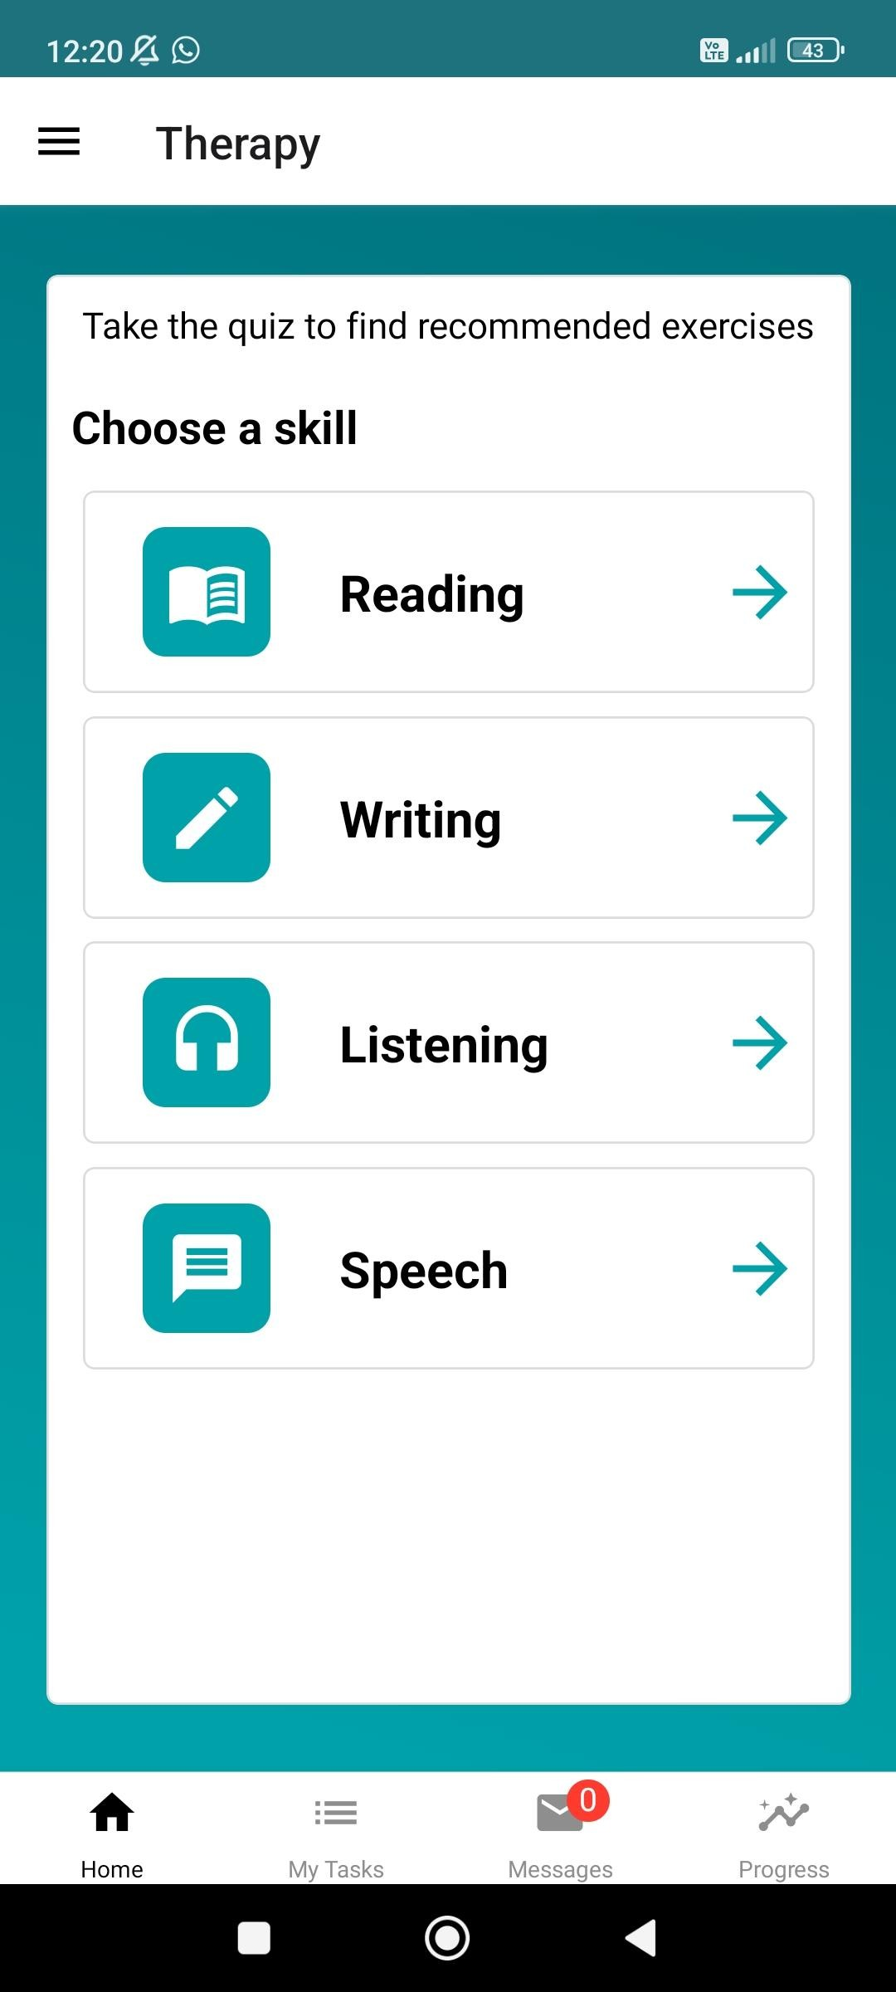

**Large, Clear Text and Buttons:**  
The use of large buttons and fonts in the application is a key accessibility feature, especially for aphasia patients who may struggle with vision or reading difficulties. The ease with which users can navigate through the app using these large text and buttons contributes to its user-friendly nature. The large, simple icons that provide quick access to the app’s core functions allow users to reach what they need without exerting too much effort.

For users with weaker reading and writing skills, these large, clear texts can be highly beneficial. Additionally, the absence of unnecessary information in the interface, presenting only essential text, is another advantage.

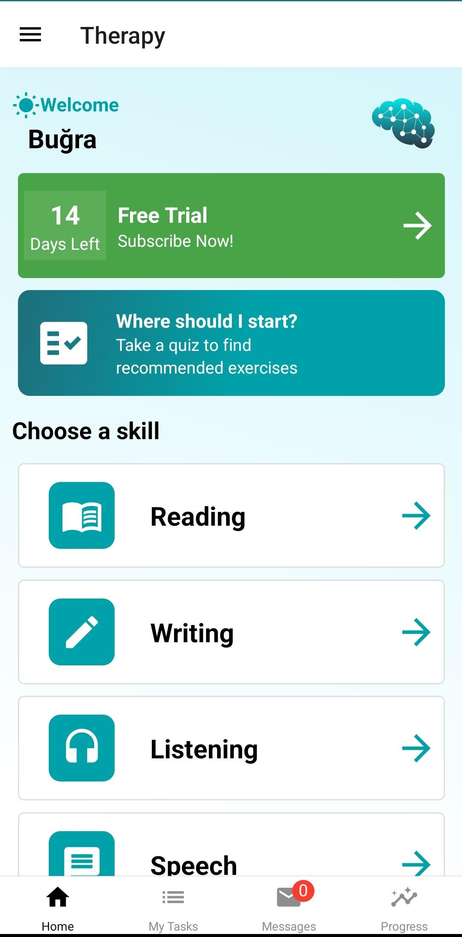

**Video-Based Therapy:**  
The app provides therapy through video, allowing users to practice verbal communication. Visually supported lessons can be especially effective in overcoming the comprehension difficulties that aphasia patients frequently face when developing their language skills. Through these videos, the combined use of auditory and visual elements makes learning more effective by allowing users to both hear and see the language.

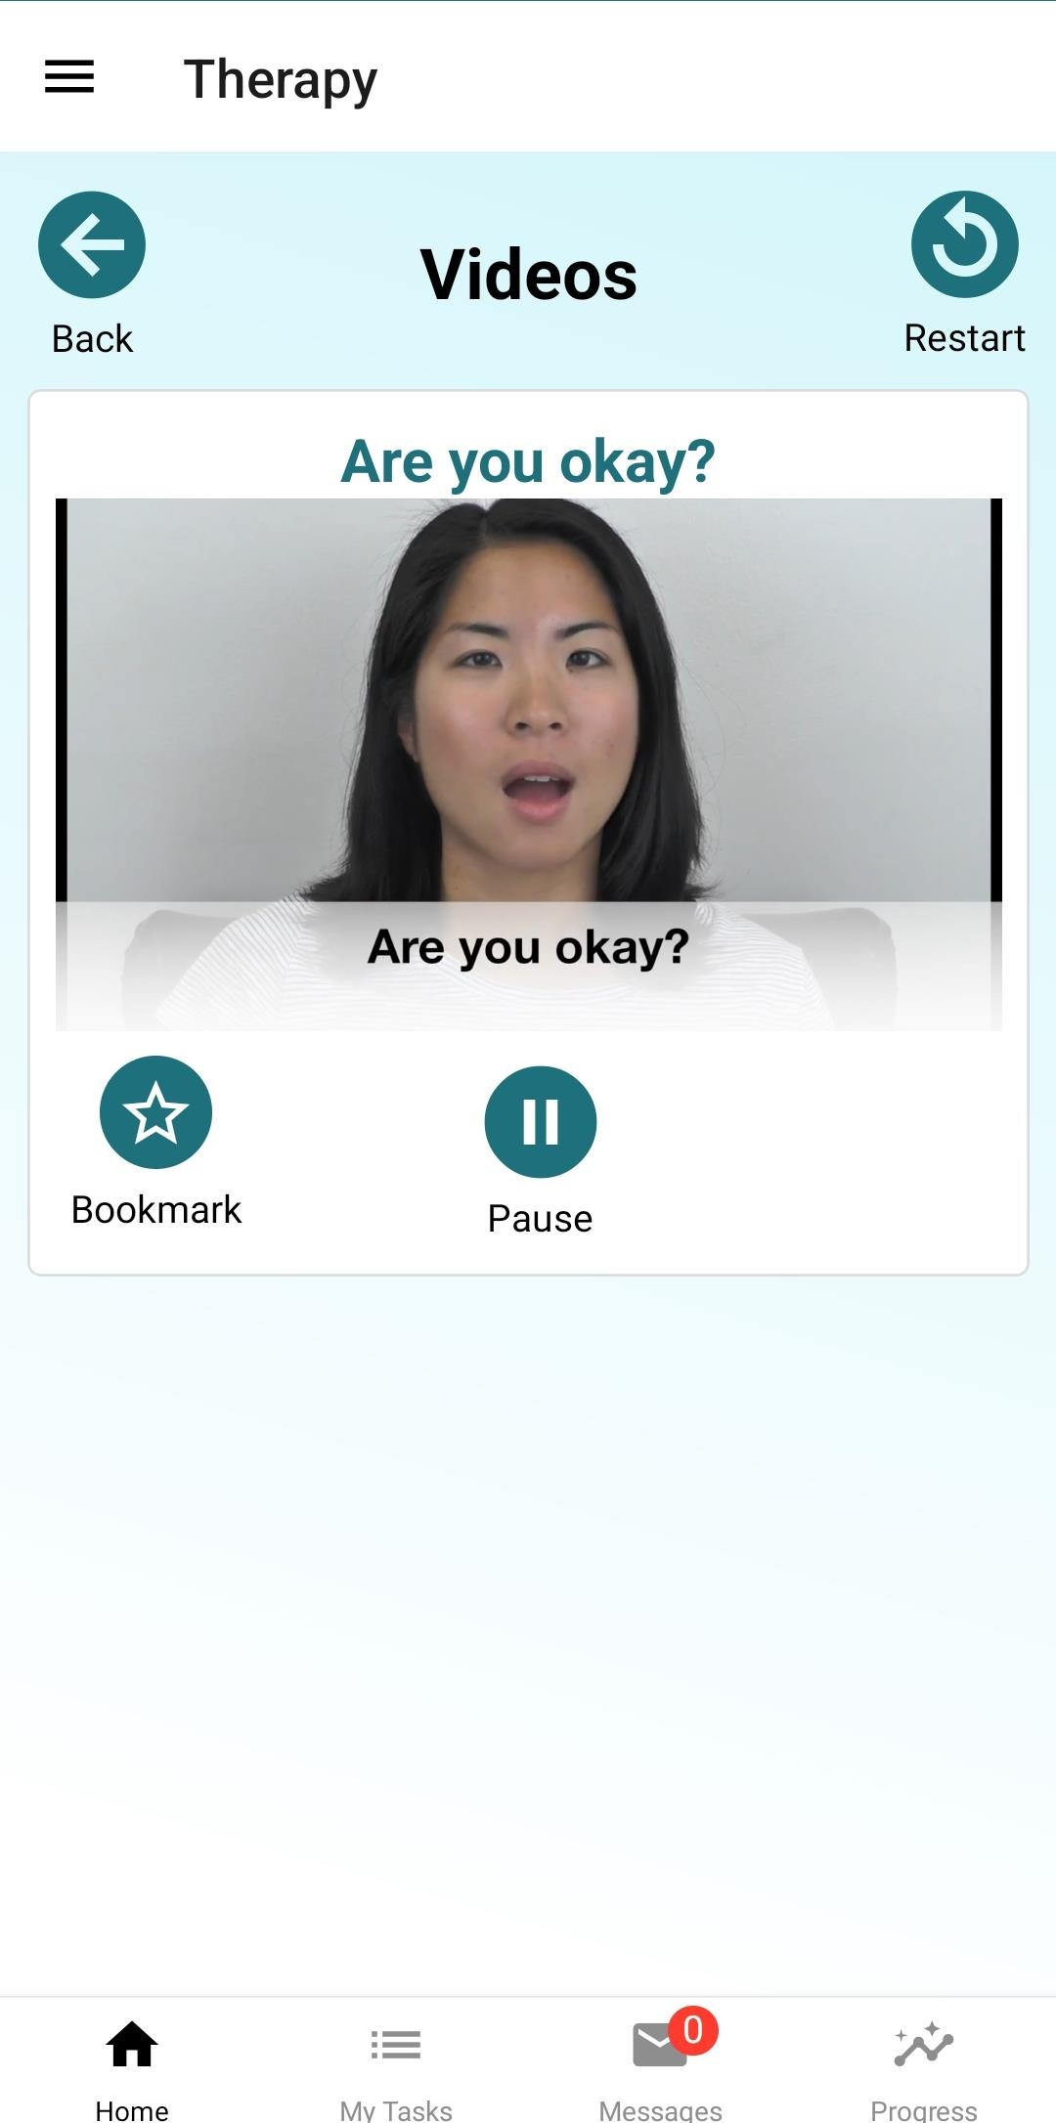

Additionally, the clear and simple presentation of videos and the precise pronunciation of words provide users with accurate examples, helping them improve their language skills. The slow and deliberate speech of the speakers in the videos is particularly noteworthy; this is an essential feature for aphasia patients.

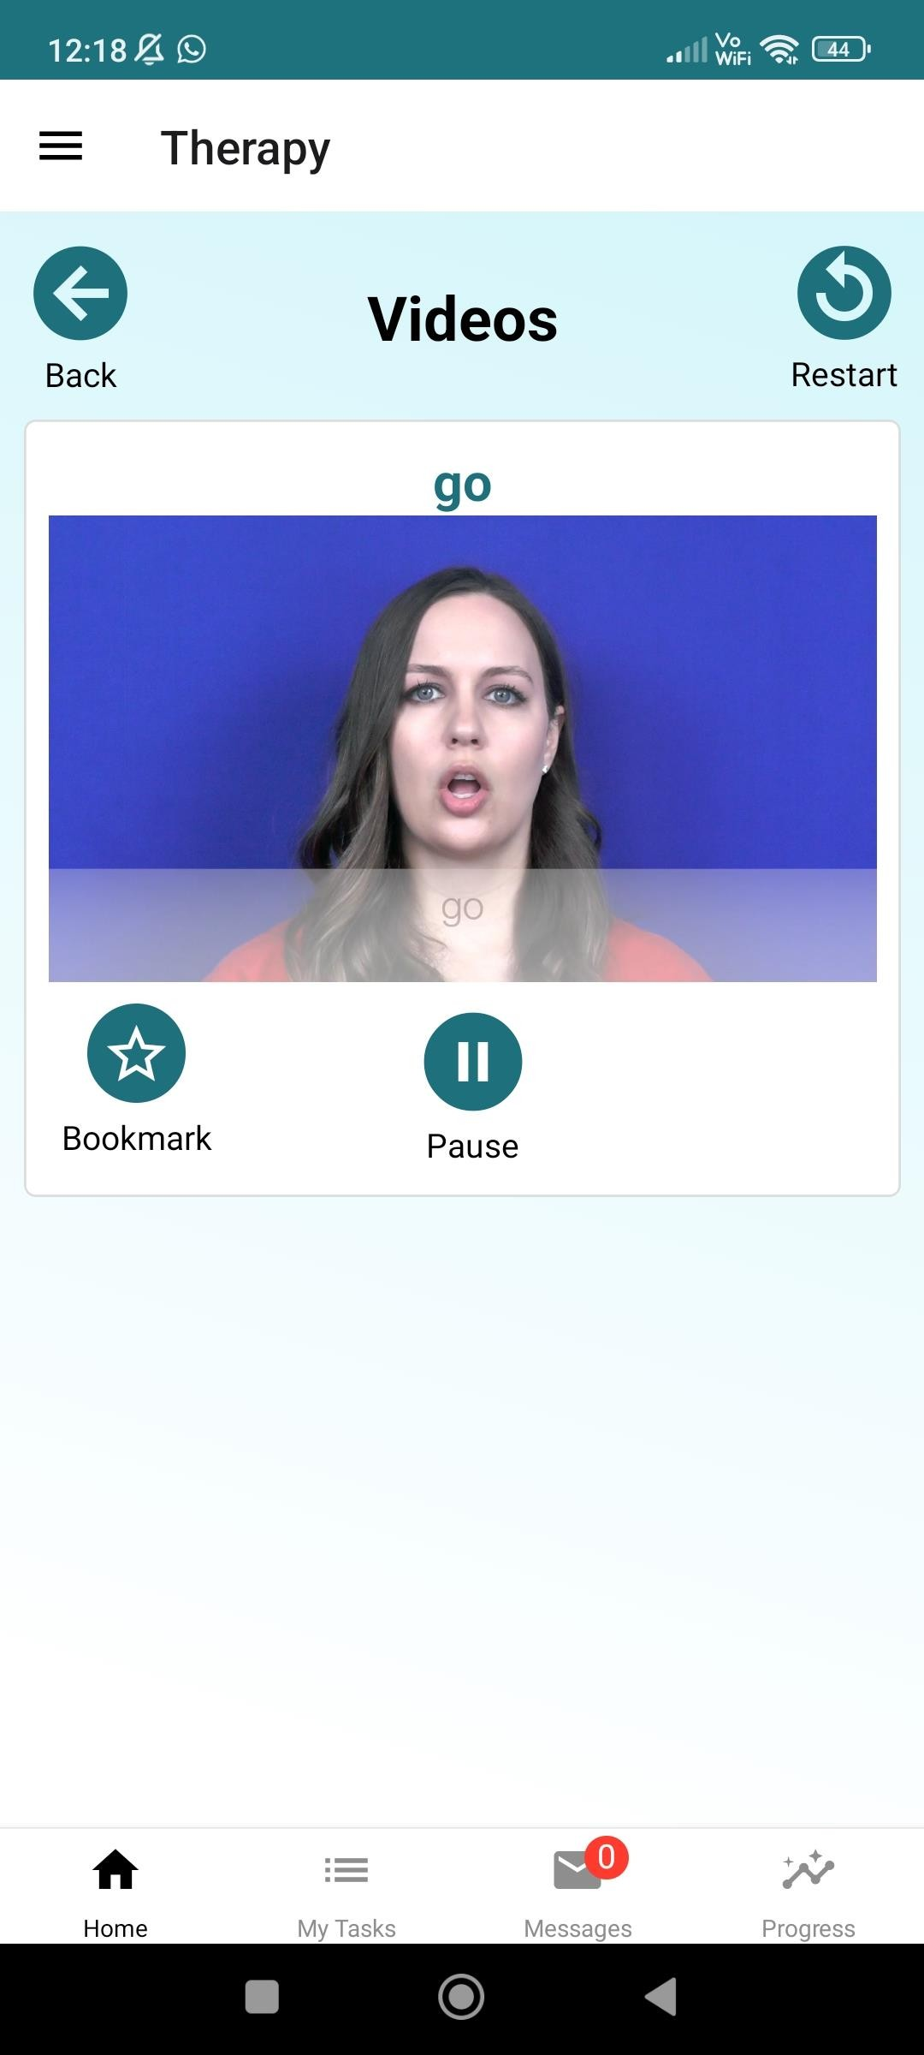

**Bookmark Feature:**

The app includes a "Bookmark" feature that allows users to mark videos. This enables them to easily access the videos they wish to repeat or frequently use. Language therapy is built on repetition, and the ability to bookmark and frequently watch specific videos helps users practice regularly, thus accelerating their learning process.

This feature is especially beneficial for users in organizing their therapeutic progress and gaining quick access to specific exercises.

By clicking the star next to a word, users can add it to their favorites. This allows patients to quickly access words they find challenging.

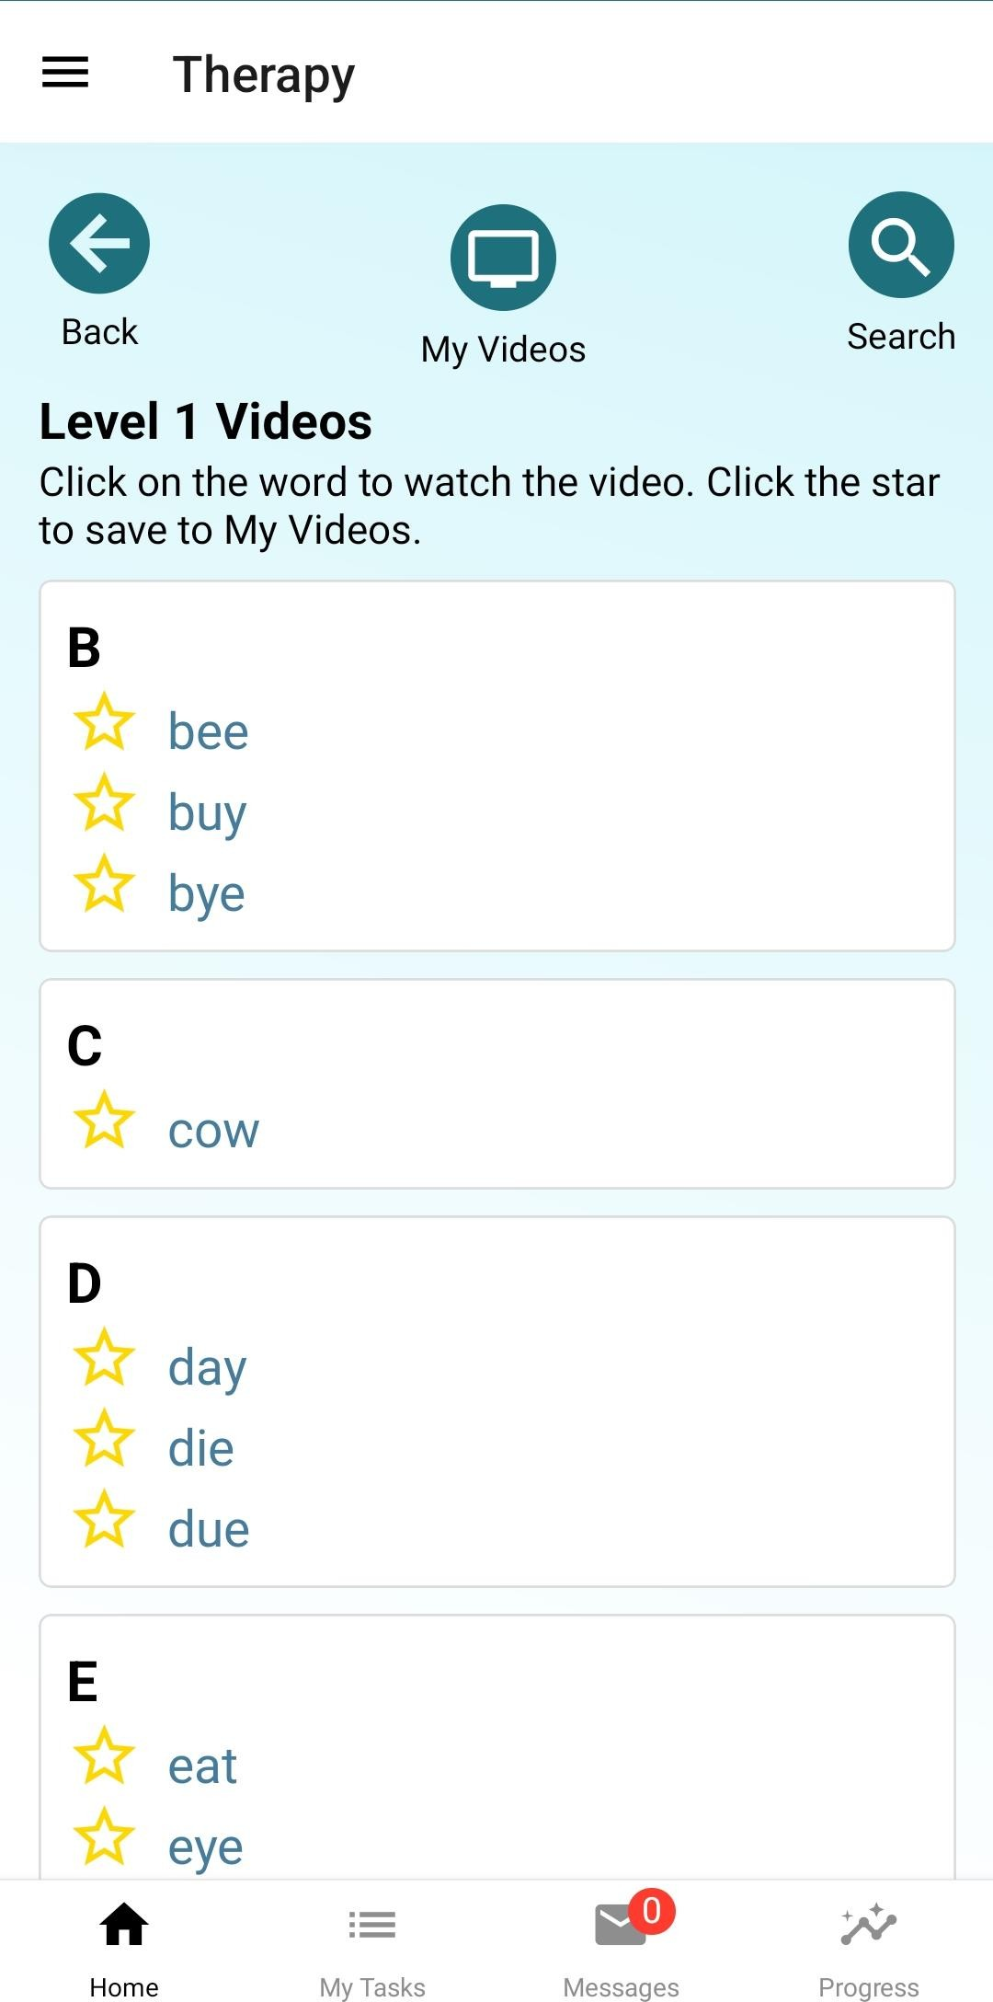

**Weaknesses**

**Lack of Feedback:**

The app appears to lack an interactive feedback mechanism. Users can only watch and repeat the videos, but there is no system for real-time feedback. For instance, a feature that allows users to record their own pronunciation and receive feedback from the app could be added. This would provide an opportunity for users to recognize and correct their mistakes, resulting in a more effective learning process.

**Error Messages:**

Some screenshots show error messages being presented in an overly simple way. More descriptive error messages could be provided to users. For example, if users are informed about why they encountered an error and how to resolve it, they would face fewer issues while using the app. Providing guidelines or tips for resolving errors could improve the user-friendliness of the app.

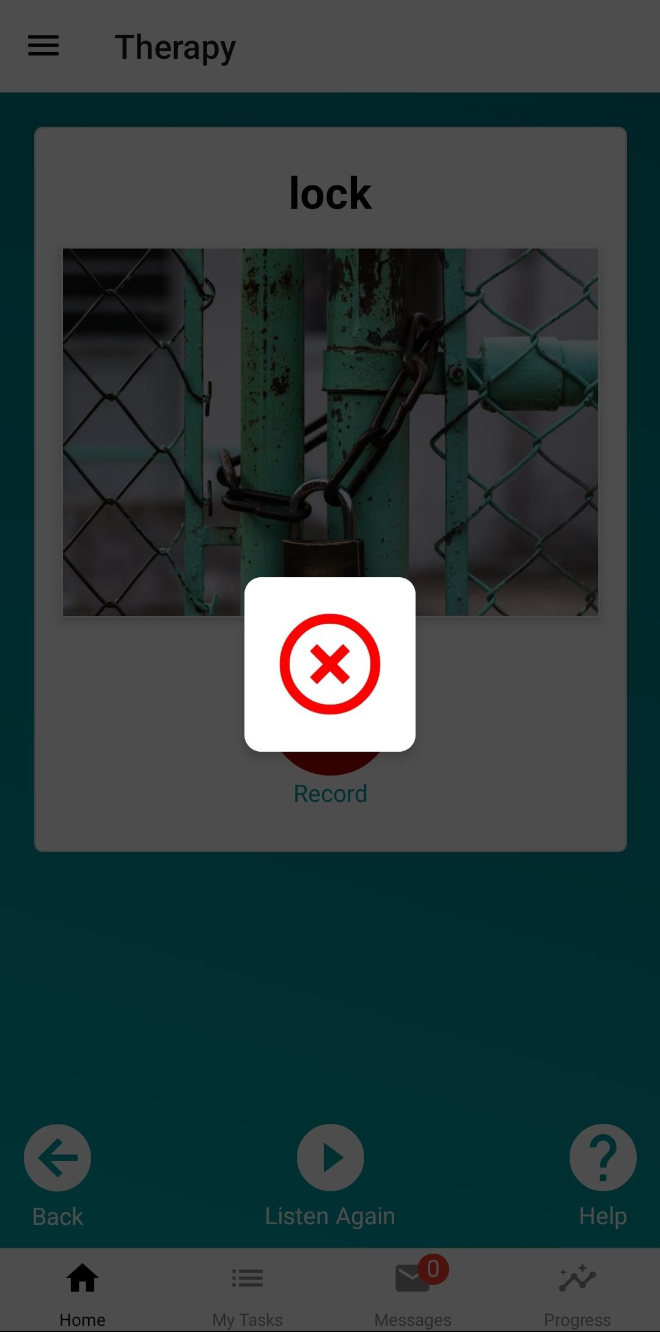

**Internet Connection Requirement:**

One major disadvantage is that the app cannot be used without an internet connection. Aphasia patients may not always have access to the internet, especially in hospitals, rural areas, or places with limited connectivity. Offering an offline mode would be crucial to ensure users can continue their therapy without interruptions.

Relying on an internet connection may cause disruptions in users’ therapy sessions, negatively impacting their language development. Offline functionality would make the app more accessible and user-friendly.

As seen on the screen, when I turned off my internet connection, the video-based exercises in the app stopped loading. This can interrupt pronunciation practice for patients without a stable internet connection and cause disruptions in therapy.

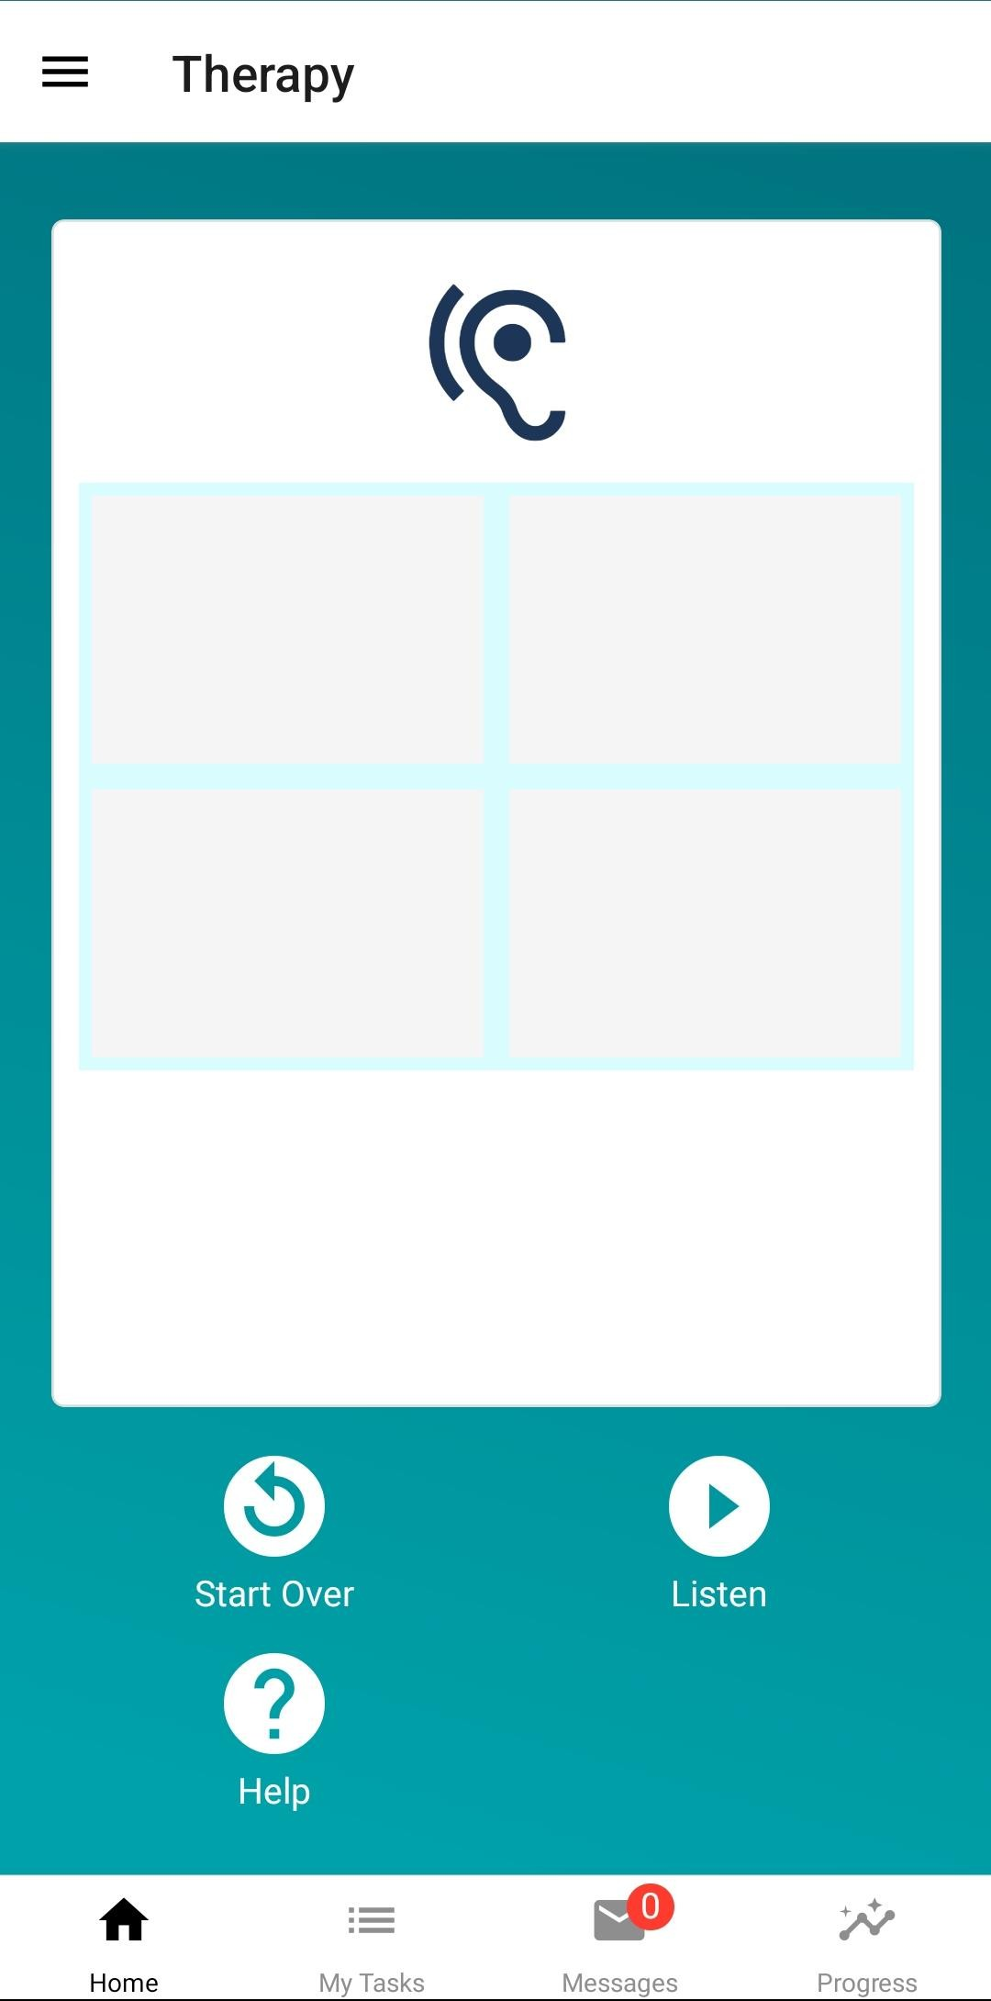

APP-2: Language Therapy Lite

metin, ekran görüntüsü, yazılım, multimedya içeren bir resim

Açıklama otomatik olarak oluşturuldu

The **Language Therapy Lite** app is a speech therapy tool designed to help individuals improve their language skills, particularly those with aphasia, brain injury, or communication difficulties. Developed by Tactus Therapy Solutions, this app offers a preview of the full version by providing free exercises from four key therapy modules.

**Features and Services:**

1. **Comprehension Therapy:** Aims to improve listening and reading skills. Users work on activities such as listening to words and selecting the corresponding image or finding the related word by both listening and reading.
2. **Naming Therapy:** Includes exercises that improve object naming and word-finding skills. Users can expand their vocabulary through activities supported by helpful prompts.
3. **Reading Therapy:** Offers practice at both the sentence and word level, helping to improve attention and independent reading skills.
4. **Writing Therapy:** Provides exercises that enhance writing and spelling skills. Users can practice by completing missing letters or arranging letters in the correct order.

Each module offers customizable activities, performance tracking tools, and varying difficulty levels, making the app suitable for use at home or in a clinical setting. The app supports multiple languages, including English, Spanish, German, and French.

**Pros:**

* **Backed by scientific research:** Proven to improve aphasia symptoms with regular use.
* **Customization options:** Users can personalize activities by adding their own photos or words.
* **One-time purchase:** No subscription is required, allowing unlimited use after a single purchase.
* **Suitable for clinical needs:** Offers progress tracking and easy usability for therapists.

**Cons:**

* **Limited content in the Lite version:** The full version must be purchased for more comprehensive use.
* **Requires regular use:** Daily use is necessary for the best results, which might be challenging for some users.

metin, ekran görüntüsü, mobil telefon, küçük alet içeren bir resim

Açıklama otomatik olarak oluşturuldumobil telefon, ekran görüntüsü, multimedya, İletişim Cihazı içeren bir resim

Açıklama otomatik olarak oluşturuldumobil telefon, metin, taşınabilir haberleşme cihazı, küçük alet içeren bir resim

Açıklama otomatik olarak oluşturulduelektronik donanım, metin, ekran görüntüsü, küçük alet içeren bir resim

Açıklama otomatik olarak oluşturuldumetin, mobil telefon, küçük alet, ekran görüntüsü içeren bir resim

Açıklama otomatik olarak oluşturuldu

APP- Aphasia Talk Help Text Speech

metin, ekran görüntüsü, mobil telefon, multimedya içeren bir resim

Açıklama otomatik olarak oluşturuldu

The Aphasia Talk Help Text Speech app is designed to assist individuals with aphasia or speech difficulties in communicating. The app allows users to write text and convert it to speech, while also providing visual aids where users can click on words or phrases for auditory playback.

**Features:**

* **Text-to-Speech:** Users can hear the text they have written through the app.
* **AI Predictive Text:** Offers suggested words while typing.
* **Customization:** Allows users to add new images and phrases.
* **Hand-drawing:** Provides the ability to draw by hand to facilitate communication.

**Pros:**

* Easy-to-use interface with customizable content.
* Supports daily communication, enhancing quality of life.
* Can speed up recovery after aphasia.

**Cons:**

* Consistent use is required for full performance.
* In-app purchases may be needed to access all features.

mobil telefon, ekran görüntüsü, mobil cihaz içeren bir resim

Açıklama otomatik olarak oluşturuldumobil telefon, ekran görüntüsü, mobil cihaz, taşınabilir haberleşme cihazı içeren bir resim

Açıklama otomatik olarak oluşturulduekran görüntüsü, mobil telefon, mobil cihaz, İletişim Cihazı içeren bir resim

Açıklama otomatik olarak oluşturuldumetin, ekran görüntüsü, mobil telefon içeren bir resim

Açıklama otomatik olarak oluşturuldu